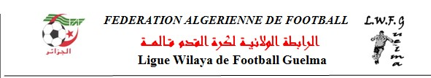
DIRECTION TECHNIQUE WILAYA
القائمة الأولية للناجحين في اختبار الولوج الى التكوين الفدرالي FAF 1
NO | NOM PRENOM | MOYENNE | OBSERVATION
01 | DJEDI YASSINE | 06 | ADMIS
02 | BENARBIA CHEMSEDDIN | 06 | ADMIS
03 | HAOUES RAFIK | 07 | ADMIS
04 | DJEBAR WAIL | 5.33 | ADMIS
05 | BOURIACHI MEHDI | 07 | ADMIS
06 | KERDOUCI NABIL | 7.66 | ADMIS
07 | SERIDI HANI | 7.33 | ADMIS
08 | CHEKATTI NASR.EDDINE | 08 | ADMIS
09 | AOUISSI MOHAMED | 7.33 | ADMIS
10 | MAIZI AKRAM | 06 | ADMIS
11 | BOUACHERIA MED FAKHR ELISLEM | 7.33 | ADMIS
12 | BEHLOUL YOUNES | 5.66 | ADMIS
13 | AOUAMRI FARIS | 6.66 | ADMIS
14 | LADASSI MOHAMED | 6.66 | ADMIS
15 | BENAMIRA SLIMANE | 07 | ADMIS
16 | BELHIMEUR ZINE EDDINE | 05 | ADMIS
17 | BEDBOUDI KHALED | 05 | ADMIS
18 | OUCIF FATMA ZOHRA | 7.66 | ADMIS
19 | MESSIOUD WASSIM | 07 | ADMIS
20 | BOUBAKEUR MOHAMED SALAH | 05 | ADMIS

LE DTW/ REBBAHI NASSEREDDINE
